**Notes regarding Transport Arm**

The image below shows the available space to place the motor:

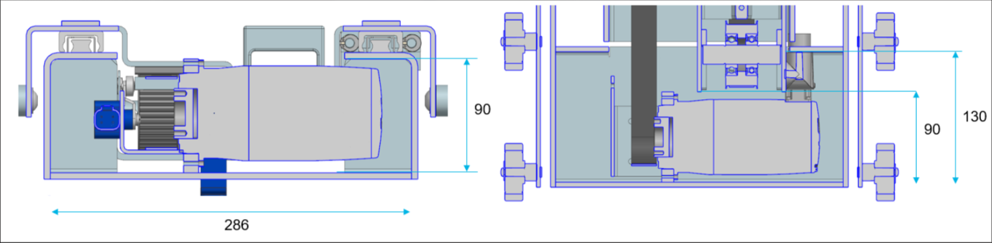

Image below shows a schematical representation of the application:

